Guía2. Desarrollo Proyecto APT
Asignatura Capstone

1. Resumen avance Proyecto APT
A continuación, encontrarás distintos campos que deberás completar con la información solicitada.

Project APT Progress Summary | To date, the project has progressed through essential stages, including planning, design, and initial development.  During the planning phase, team roles were clearly defined, and meetings were conducted with the client to understand the institutional needs and the issues present in the current system. Based on this information, the project vision was established, and both functional and non-functional requirements were identified, validated, and organized into the product backlog and sprint backlog. This allowed the team to clearly structure the specific objectives and scope of the project.  In the first design and development sprint, the team successfully completed the 4+1 architectural views (class diagram, sequence diagram, component diagram, deployment diagram, and use case diagram), as well as the BPMN model for administrative processes. Additionally, various mockups and user interface designs were developed, including the login module, administrator dashboard, student portal, teacher portal, and payment interface. At present, mockups for the grade-entry system and academic calendar are in progress.  Regarding the database implementation, progress has been temporarily delayed due to incomplete data provided by the client (specifically missing information related to teachers and administrative staff). To prevent interruptions in development, the team prioritized tasks not dependent on the database, such as interface design and backend structure, while awaiting the remaining information.  In terms of backend development, the authentication logic and login functionality have been successfully implemented, establishing a secure access flow for the system and preparing the structure for future database integration. Development of the administrator management module (including user modification and fee creation features) has also begun; however, full completion remains dependent on the final database structure.  Overall, the project continues to advance according to its objectives, with key foundational components completed and pending tasks organized to ensure continuity once the missing client data is received.
Objectives | The objectives established in the initial phase of the project remain unchanged, with no modifications made to date.
Methodology | Due to incomplete information provided for the database structure (specifically regarding teachers, subjects, and administrative users), a methodological adjustment was implemented. This consisted of prioritizing development tasks that did not depend on the database — such as interfaces, mockups, and the login backend — in order to optimize development time while awaiting the missing data from the client.
Progress Evidence | The evidence for our intranet project is presented across multiple platforms and formats, demonstrating the progress, organization, and quality of the work completed.  Tools:  • GitHub: Used to host the system's source code. This platform provides evidence of development progress, proper backend structure, and effective use of version control practices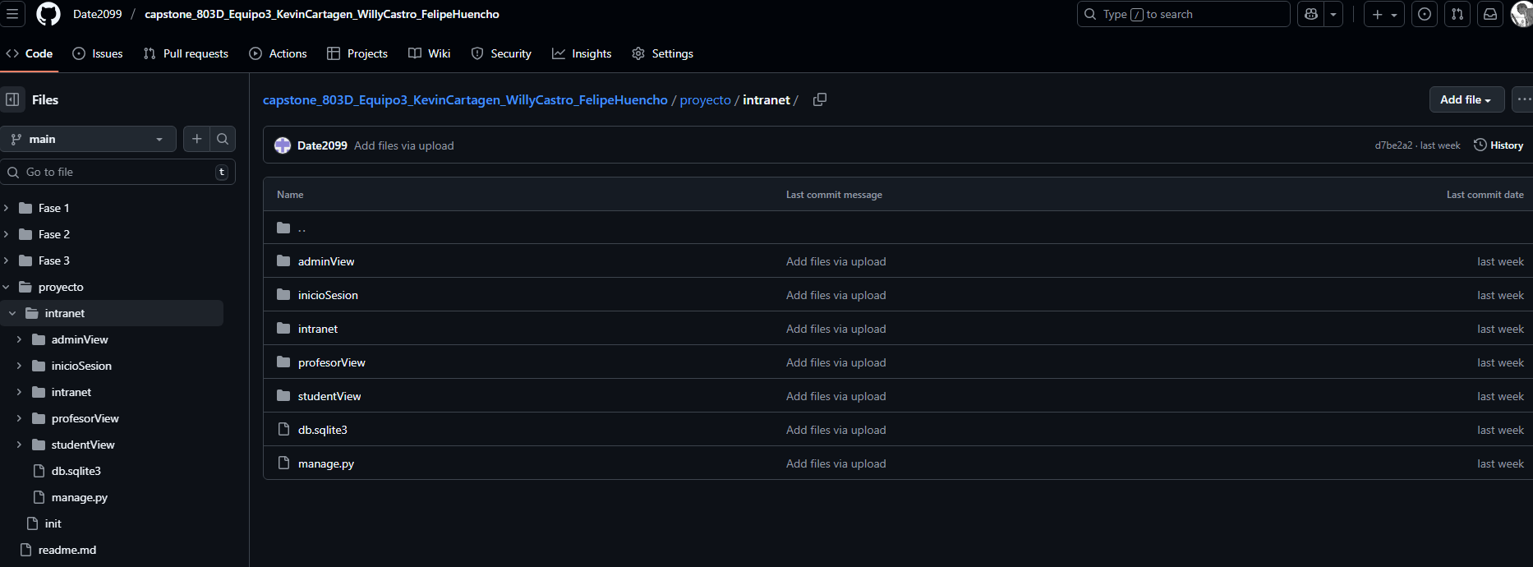  Trello: Used as the primary project management tool. This platform contains development evidence, progress tracking, future planning, and meeting logs, including screenshots and team activity records. Its use demonstrates the application of agile methodologies in organizing and managing the project 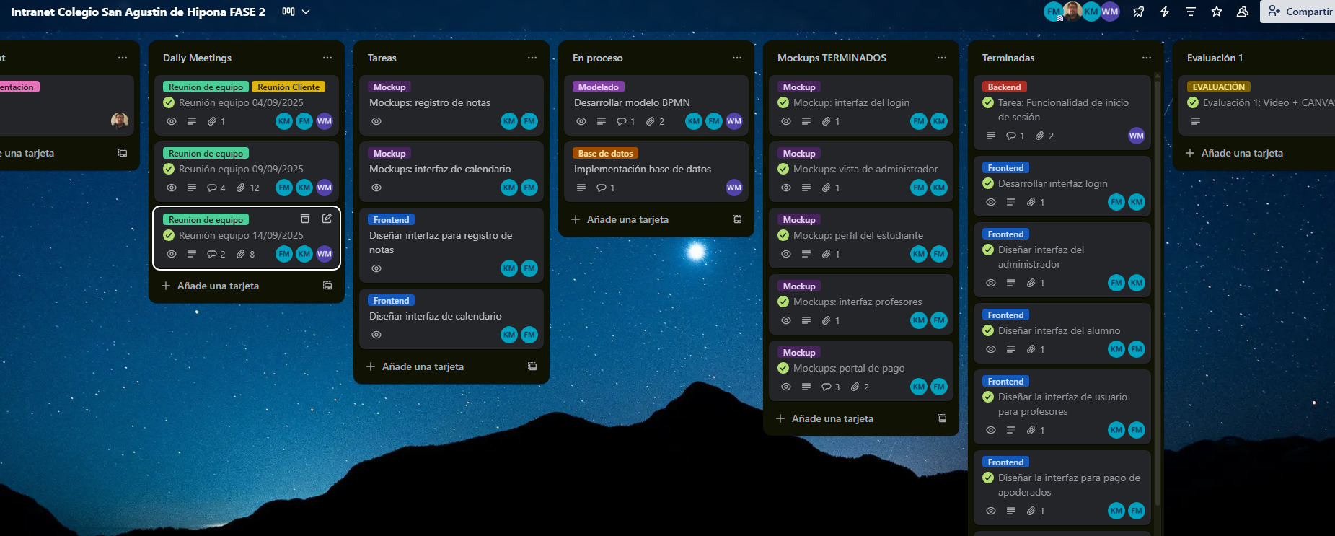  4+1 Architecture Diagrams: These diagrams represent the system architecture from multiple perspectives (logical, development, process, physical, and scenarios), ensuring that the solution is built on a solid and scalable design foundation.  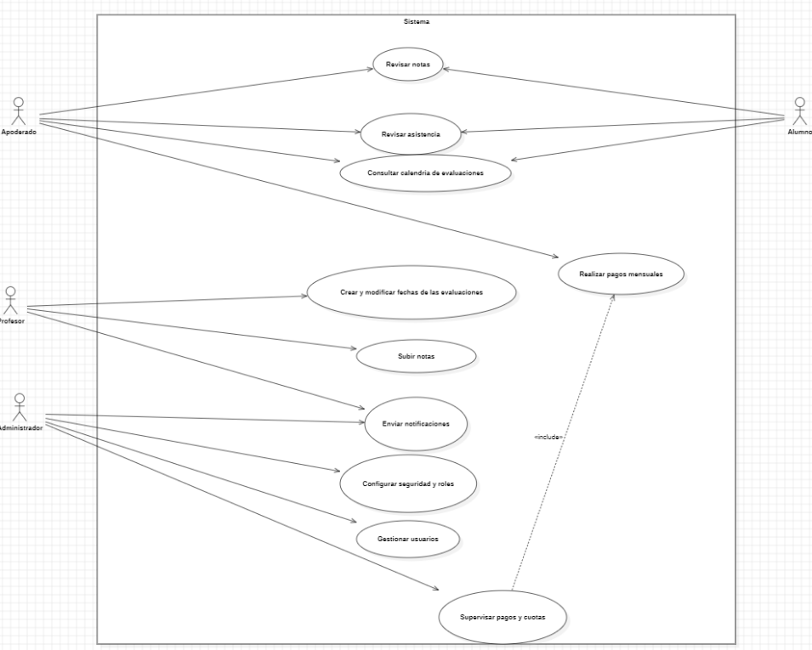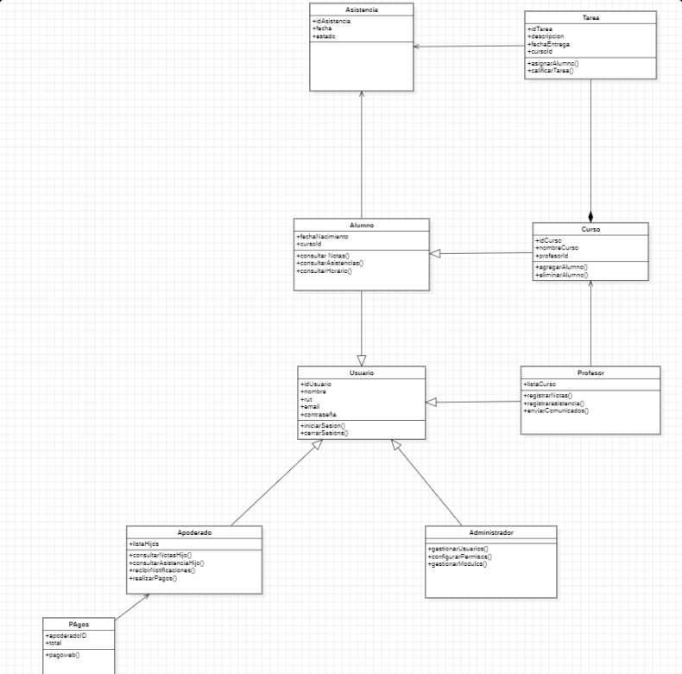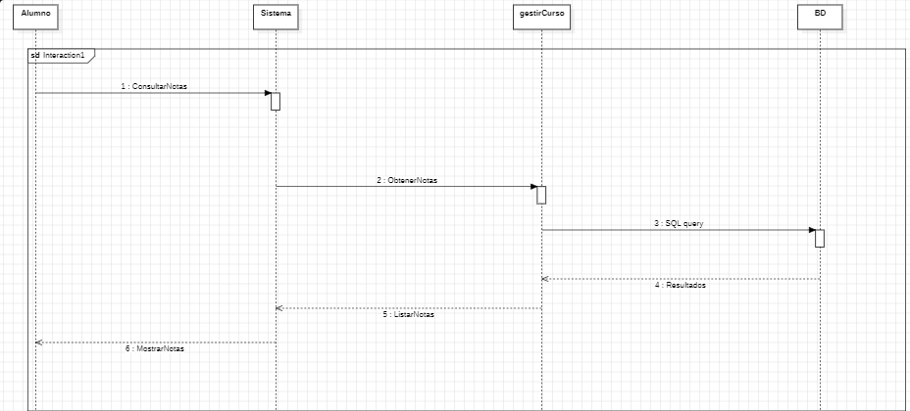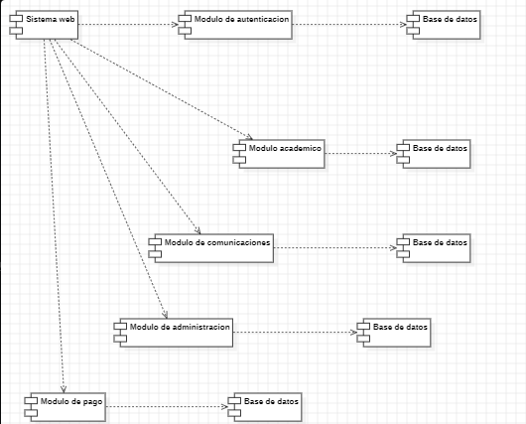  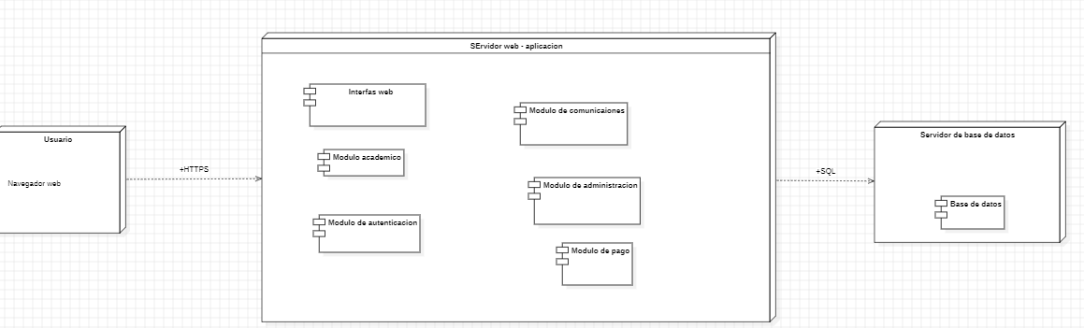  BPMN Model: Business process diagrams that allow visualization and understanding of how the system will support the institution's administrative and academic workflows, ensuring alignment between organizational requirements and the software solution. (So far, the login process, backend flow, and administrator process model have been completed.)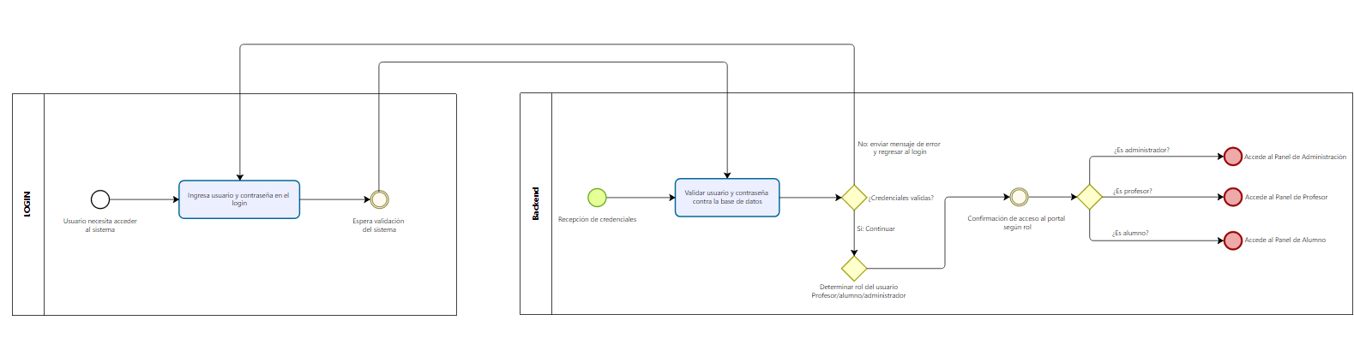  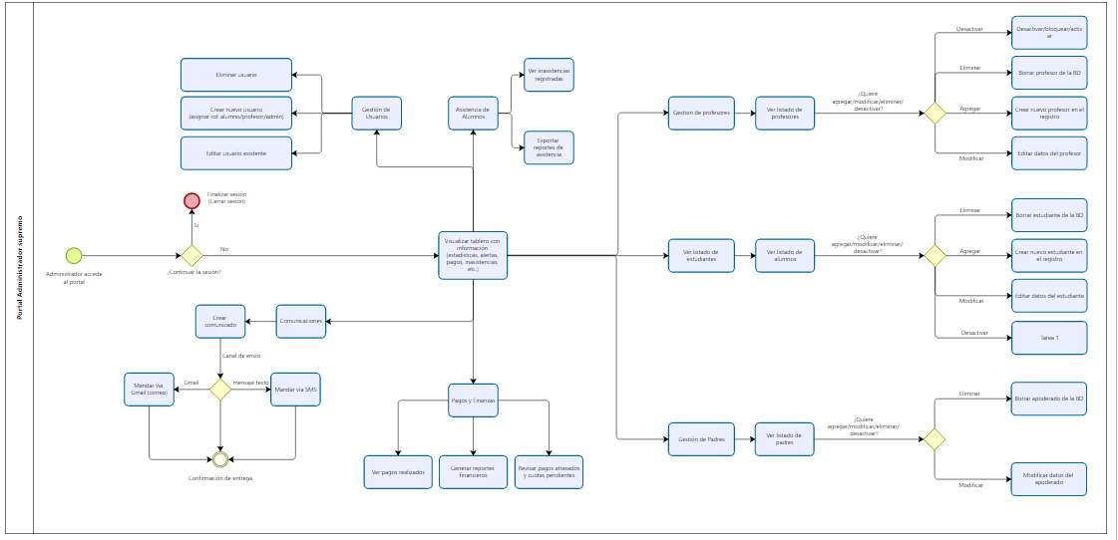  - Database Design (in progress): As an essential component of the solution, the data model is being developed and will be followed by the implementation of the relational database. This evidence will demonstrate how academic information will be structured and stored within the system.  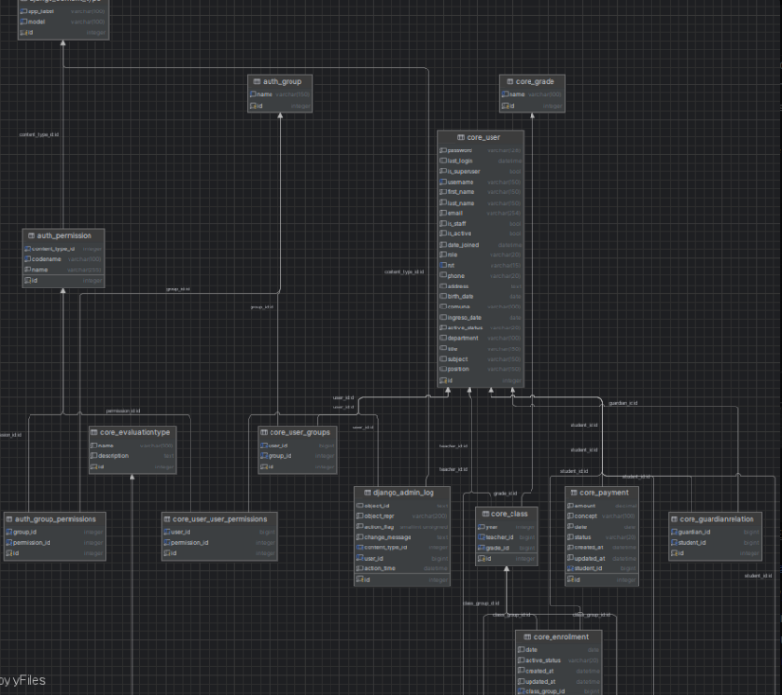
2. Monitoreo del Plan de Trabajo
Examina cuidadosamente tu plan de trabajo, enfocándote especialmente en la columna de estado de avance y ajustes.

Plan de Trabajo Proyecto APT
Competencies / Skill Areas | Nombre de Actividades/Tareas | Activities / Tasks | Resources | Duration | Responsible | Observations
IT Project Management / Software Project Coordination | Phase 1: Planning and Design |  |  | 4 Weeks
 | 1.1. Requirements Definition and Project Planning | Conduct meetings with the client to define the full list of system functionalities (Product Backlog). Establish the detailed work plan and configure project management tools. | Video conferencing tools (Zoom/Meet), project management software (Trello) |  | Entire Team | Facilitator: Close communication with the client. Challenge: Scheduling availability for initial meetings.
Software Development / Web Technologies Integration | Phase 2: Iterative Development (Sprints) |  |  | 9 Weeks
 | 2.1. Development Environment Setup | Install and configure all necessary tools: IDEs, database engine, version control system, and frameworks. | Personal computers, internet access, software installers (VS Code, Git, etc.) |  | Entire Team | Essential to standardize development environments across the team.
Database Modeling / Software Development | 2.2. Backend & Database Implementation | Develop business logic, REST API, role-based authentication system, and begin implementing the physical database structure. | Backend framework (e.g., Django), database tools (PostgreSQL), |  | Willy Castro | Challenge: Secure handling of sensitive student information.
UI/UX / Front-End Development | 2.3. User Interface Development | Design and implement user interfaces for all modules (login, notes, payments, etc.), ensuring an intuitive user experience. | UI design tools (Figma), HTML/CSS/JS, component libraries |  | Felipe Huencho | The UI must be simple and accessible for users with different levels of technical ability.
Software Development / Web Integration | 2.4. Continuous Integration & Unit Testing | Connect frontend components with backend API and run unit tests to ensure quality and correct functionality. | Git, testing tools (e.g., PyTest/Jest), GitHub |  | Todo el equipo | Requires clear communication between frontend and backend roles.
Project Management / Agile Software Delivery | Phase 3: Testing, Deployment and Closure |  |  | 4 weeks
 | 3.1. Integration Testing & User Acceptance Testing (UAT) | Conduct full system testing and present the platform to the client for final validation and feedback. | Staging environment, test scripts, direct client feedback |  | Entire Team | Challenge: Remote client support handled via virtual meetings and demonstrations..
Technical Documentation / Software Delivery | 3.2. Final Documentation Development | Prepare technical manual (installation, configuration) and user guides for each platform role.. | Word processor, screenshot tools. |  | Entire Team | Can be executed in parallel with final tests and deployment.
Web Hosting / Deployment | 3.3. Deployment & Formal Delivery | Configure production server and deploy the final system. Conduct formal project hand-off to the client and instructor. | Server hosting (AWS Lightsail), SSH/FTP client, domain configuration |  | Entire Team | Deployment may involve unexpected technical challenges.

Factors That Have Facilitated and/or Challenged Development
Facilitating Factors
- Agile Methodologies:
The use of Trello as the primary project management tool enabled clear organization of tasks, progress tracking, and scheduling, demonstrating correct application of agile methodologies.
- Version Control:
GitHub was essential for hosting the source code, visualizing development progress, maintaining an organized structure, and efficiently managing team collaboration.
- Initial Planning:
Clearly defining team roles and conducting effective client meetings from the beginning allowed us to establish a solid project vision and accurately capture requirements.
- Team Flexibility:
The team's ability to adapt and reorganize tasks when necessary was key to maintaining progress even when unexpected challenges arose.
Challenging Factors
- Incomplete Client Data:
The main challenge was the lack of complete data provided by the client, particularly missing records for teachers and administrators. This directly halted the design and implementation of the database.
- Task Dependencies:
As a result of the incomplete data, essential features such as student, teacher, and payment management could not begin or were delayed, since they depend on a finalized database structure.
To overcome the issue of incomplete data, the team implemented the following actions:
- Methodological Adjustment:
We prioritized tasks that did not depend on the database, including interface design, mockups, and initial backend (authentication) development.
- Client Communication:
Additional meetings with the client were scheduled to clarify and obtain the missing information required to complete the database design.
- Use of Simulated Data:
We decided to work with mock/test data in a controlled environment to advance unit testing and ensure faster integration once the real database information is finalized.

Adjusted or Eliminated Activities:

No activities from the original work plan have been eliminated, as all tasks defined during the planning phase remain essential for achieving the project objectives.
However, a methodological adjustment was made regarding the execution order of activities. This change was necessary due to incomplete data provided by the client for the database design (specifically missing records for teachers, administrators, and subjects), which prevented progress according to the original timeline for the database implementation.
To avoid delays, the team prioritized tasks that did not depend on the database, such as developing mockups, user interfaces, and the initial backend for login and authentication. This adjustment allowed the team to continue delivering tangible progress while waiting for additional client meetings to finalize the database structure.

Activities Not Started or Delayed
Some planned activities could not begin within the scheduled dates mainly due to the lack of a finalized database design. This delay affects modules such as database creation and, subsequently, the student, teacher, and payment management modules. Since these functionalities directly depend on having a complete and validated data model from the client, the team has focused on progressing with related tasks that do not require the final database structure.
Strategies to move forward:
- Prioritization of database-independent tasks: Continue advancing the design of interfaces, mockups, and backend logic that does not depend on the missing data.
- Client iterations: Maintain periodic meetings with the client to gather and validate the information required to complete the database.
- Simulation: Use test or simulated data in a controlled environment to progress with unit tests and functionality validation, ensuring faster integration once the real database is completed.
- Flexible schedule management: Reorganize activities to avoid affecting sprint deliverables and ensure ongoing system development without delays.

